**MinXSS CubeSat Pass Generation Code**

Root Directory for this IDL code is $minxss_dir/code/sat_pass/

**minxss_satellite_pass.pro** Calculate the MinXSS Cubesat pass times over Boulder

INPUT: date_range is in Julian dates; default is the next 2 weeks

OUTPUT: pass information is stored as IDL save set and HTML table

This is expected to be run once a week on Mac to generate the pass information and then planning software uses these results. It can be run more frequently if planning is done more than once a week.

**USAGE**: minxss_satellite_pass, /verbose

This will do the following tasks:

1. Download latest TLE for MinXSS from space-track.org (Air Force TLE site)

2. Calculate passes for given date_range or defaults to the next 2 weeks

3. Write pass information to IDL save set and HTML table

TLE catalog and individual spacecraft TLE files are stored in $TLE_dir

The “passes” variable data are stored as IDL save sets in $TLE_dir/pass_saveset/ and with both the file name of minxss_pass_latest.sav for use by Planning software and minxss_pass_DATE_RANGE.sav for archive purposes.

The Pass information is also formatted into HTML table for access from MinXSS web site as the minxss_pass_latest.html. A copy is also stored in $TLE_dir/pass_html/ with a file name of minxss_pass_DATE_RANGE.html for archive purposes.

The $TLE_dir is currently $minxss_dir/code/sat_pass/tle/ but should move to DATA directory instead of code directory.

The “passes” structure array format is:

passes[].start_jd Julian date

passes[].start_date YYYYDOY

passes[].start_time seconds of day (UT)

passes[].end_jd Julian date

passes[].end_date YYYYDOY

passes[].end_time seconds of day (UT)

passes[].duration_minutes End_time - Start_time

passes[].max_jd Julian date

passes[].max_date YYYYDOY

passes[].max_time seconds of day (UT)

passes[].max_elevation degrees

passes[].sunlight Flag of 0 if in eclipse, 1 if in sunlight at Max Elevation

**Generic Spacecraft Location and Pass Calculators - for MinXSS CubeSat**

Root Directory for this IDL code is $minxss_dir/code/sat_pass/

**spacecraft_location.pro** Calculate the spacecraft location (longitude, latitude, altitude)

INPUT: time is in Julian dates (can be array)

OUTPUT: location and sunlight flag

**spacecraft_pass.pro** Calculate the pass times from a ground station

INPUT: date is in Julian date (can be start date and end date)

OUTPUT: pass information (start & end time, max. elevation …)

**Setup**: define TLE_dir environment and a TLE file for your satellite in $TLE_dir/

Location Validation with ISS-Tracker at http://www.isstracker.com

IDL> spacecraft_location, time,location,sunlight,/current_time,/verbose

longitude 74.433846

latitude 49.201078

distance 6770.1427

Orbit is in sunight

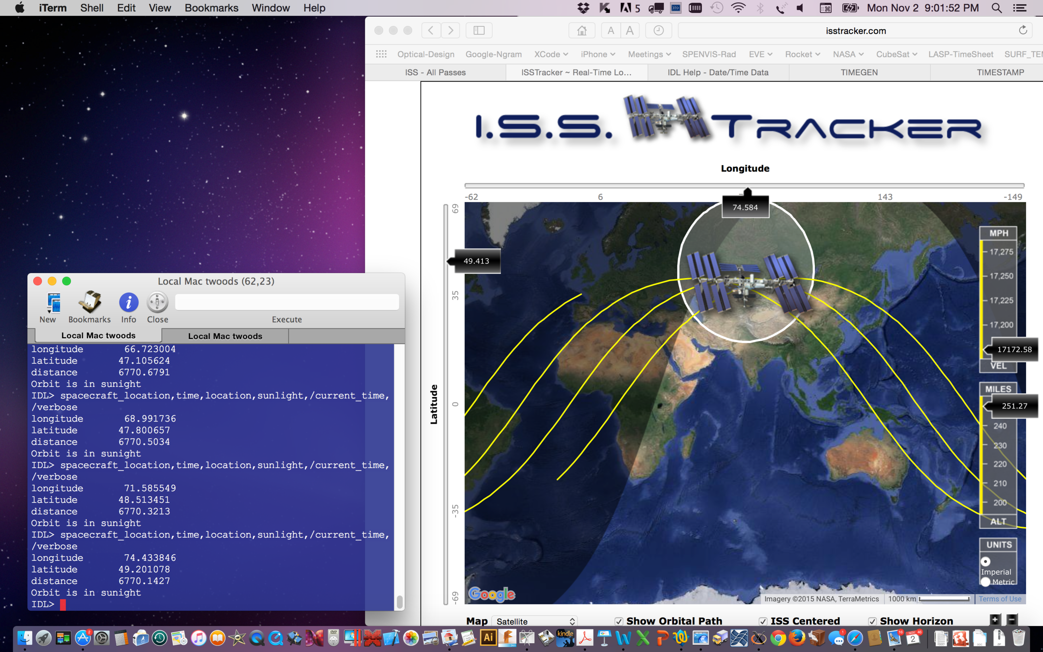

ISS Tracker Web Page provides realtime values / picture of ISS location.

Pass Validation with Heavens Above

IDL> nov5 = ymd2jd(2015,11,5)

IDL> spacecraft_pass,nov5,apass,npass,/verbose

*** TLE path = /Users/Shared/Projects/MinXSS/code/sat_pass/tle

*** Number of potential passes found = 7

*** Number of good passes found = 6

Duration Max

Pass Start_Time End_Time Min. Elev. In_Sunlight

1 2015-11-05T12:55:06UT 2015-11-05T13:05:33UT 10.47 49.83 1

2 2015-11-05T14:31:56UT 2015-11-05T14:41:55UT 9.97 22.94 1

3 2015-11-05T16:09:55UT 2015-11-05T16:18:39UT 8.75 11.06 1

4 2015-11-05T17:47:07UT 2015-11-05T17:56:29UT 9.37 15.16 1

5 2015-11-05T19:23:28UT 2015-11-05T19:34:00UT 10.53 62.83 1

6 2015-11-05T21:00:21UT 2015-11-05T21:09:17UT 8.95 13.15 1

IDL>

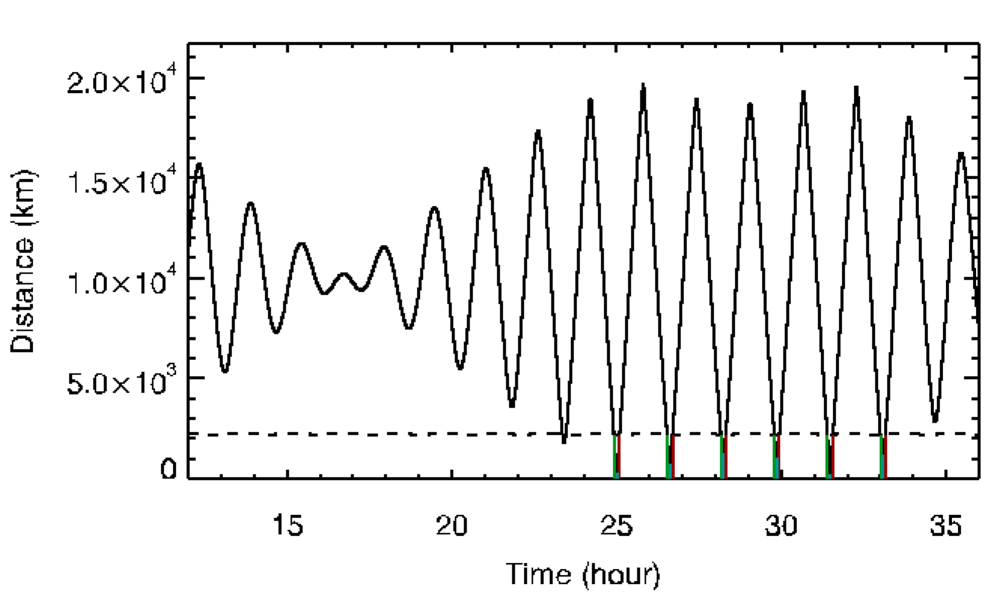

**Plot is from spacecraft_pass.pro when /verbose option is on.**

Pass options are when the distance is less than the dashed line.

Maximum Elevation has to be above 10 degrees to be selected as good pass.



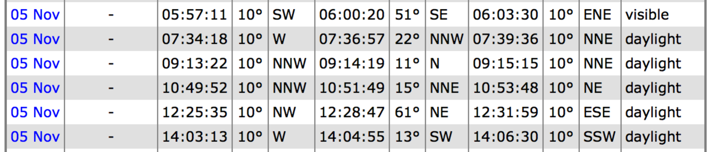

**Heavens Above Listing ISS Sightings over Boulder, CO**

Note a 7 hour offset because this is in local time, but IDL code is in UT time.

Also note that their start and end time is at 10 degree elevation, IDL starts at 0 degree.

**Downloading TLEs from Space-Track.org**

Space-Track.org is maintained by the Air Force to provide the latest TLE values for satellites. It is used by the satellite operations community and also HAM radio operators who like to track CubeSats and download beacon data.

The 3-line element file for LEO satellites is at:

<https://www.space-track.org/basicspacedata/query/class/tle_latest/ORDINAL/1/EPOCH/%3Enow-30/MEAN_MOTION/%3E11.25/ECCENTRICITY/%3C0.25/OBJECT_TYPE/payload/orderby/NORAD_CAT_ID/format/3le>

The 3-line element lists the spacecraft name and two-line-elements (TLE) for every spacecraft.

The Mac OS-X curl command can be used to download the data from space-track.org.

The IDL code tle_download_latest.pro does this curl command to download LEO satellites and searches for specified mission.

IDL> tle_download_latest, tle, mission=’MinXSS’, /output ; to download and store TLE

IDL> tle_download_latest, tle, mission=’MinXSS’, /nodownload ; to not do download